

CMPS 160 - Spring 2019

Final Project

Members: Thanut (Art) Parkeenvincha, Terence So

We hope to achieve something similar to the following screenshots of Animal Crossing (2001).

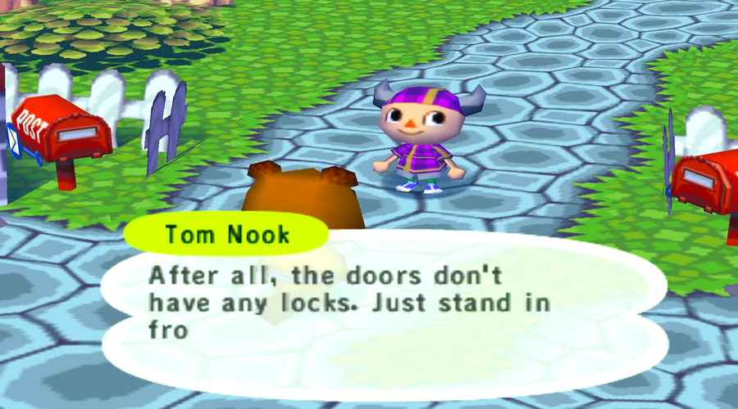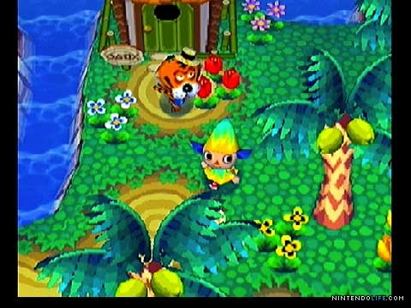

Left: The player is seen talking to one of the villagers. A text bubble pops up and the a dialogue is shown. (Implemented)

Right: The player is walking through the map as trees and flowers pass them by. Also, a villager is seen standing in front of his house. (Partially implemented)

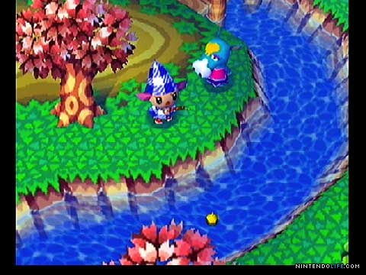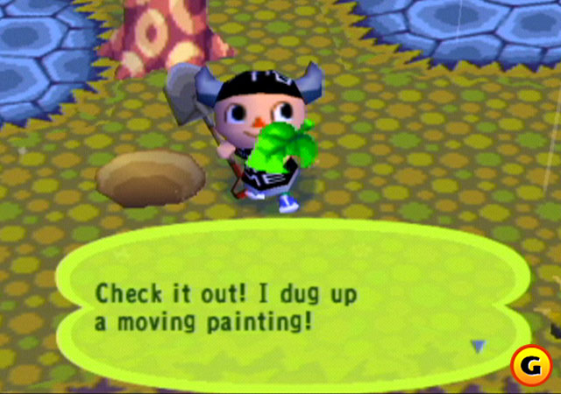

Left: The player is fishing in a river. (Not implemented)

Right: The player finished digging up a piece of furniture and a reward dialogue congratulates them. (Not implemented)